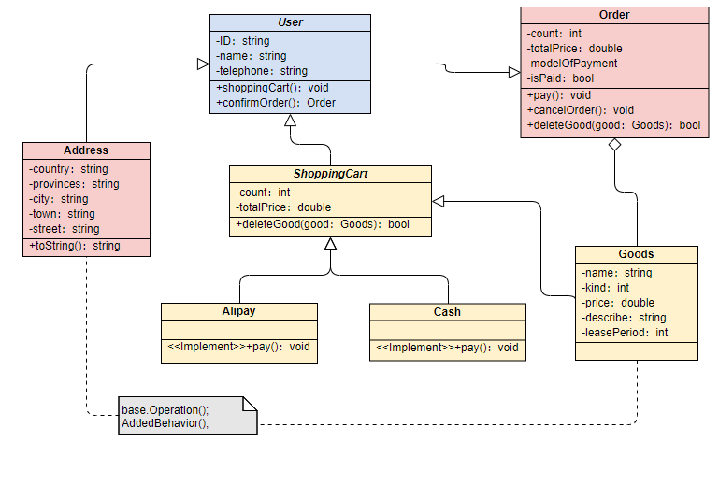

First of all, I define three properties for the User class. The user must register and then log in. I have defined five basic properties for the Goods class. The User class places an order through the Order class, selects the goods of the appropriate rental period, and adds the shopping cart through the ShoppingCart class. Then, the payment method is selected through the Alipay or Cash class, and finally determined by the Adress class. The user's address information, the rental product order is generated successfully,